OpenVAS / GVM Vulnerability Assessment Report

Task Number: 2.2 OpenVAS GVM Report
Name: Jai Bhushan Rane
Intern ID: APSPL2641663
Date: 26-07-2026

1. Definition – Quick Overview
OpenVAS (Open Vulnerability Assessment System), now part of GVM (Greenbone Vulnerability Manager), is a powerful open-source vulnerability scanner. It automatically probes systems and networks to identify security weaknesses including:
- Unpatched software and outdated services
- Misconfigurations and insecure default settings
- Weak/default credentials
- Open ports and exposed services
- Known backdoors and high-risk CVEs
- Potential attack vectors
OpenVAS/GVM is completely free and open-source, making it ideal for security testing, blue-team/red-team exercises, and educational purposes.

2. Purpose
The primary purpose of using OpenVAS/GVM is to:
- Automatically detect vulnerabilities in target systems
- Prioritize risks by severity (Critical → Low)
- Provide actionable remediation steps
- Generate professional reports for stakeholders
- Track security posture over time with re-scans
This enables security teams to fix the most dangerous issues first and make systems significantly harder to attack.
3. Setup – OpenVAS / GVM (Kali Linux)
3.1 Installation
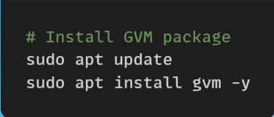

3.2 Initialization and Feed Sync
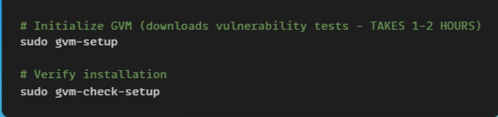

Note: Feed sync downloads over 94,000 vulnerability tests (NVTs) and can take significant time depending on internet speed.
3.3 User Management
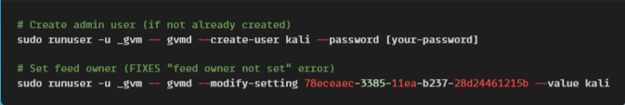

3.4 Start Services
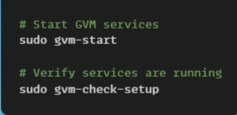

3.5 Access Web Interface
- Open Firefox in Kali
- Navigate to: https://127.0.0.1:9392
- Accept the self-signed certificate warning
- Login with:
  - Username: [your username]
  - Password: [your password]

4. Practice Scan – Metasploitable 2 (Target)
4.1 Target Details
Attribute | Value
Name | Metasploitable 2
IP Address | 192.168.225.85
OS | Ubuntu 8.04
Network | Host-Only/NAT

4.2 Scan Configuration
Setting | Value
Scan Config | Full and Fast
Port Range | All ports from 1 to 65535
Task Name | Metasploitable_Scan
Schedule | Once

4.3 Scan Steps
- Log into GSA (Greenbone Security Assistant)
- Click Scans → Tasks
- Click Task Wizard (Magic Wand icon)
- Enter: 192.168.225.85
- Click "Start Scan"
- Wait for scan to complete (1-2 hours)
- Export report as PDF

4.4 Scan in Progress
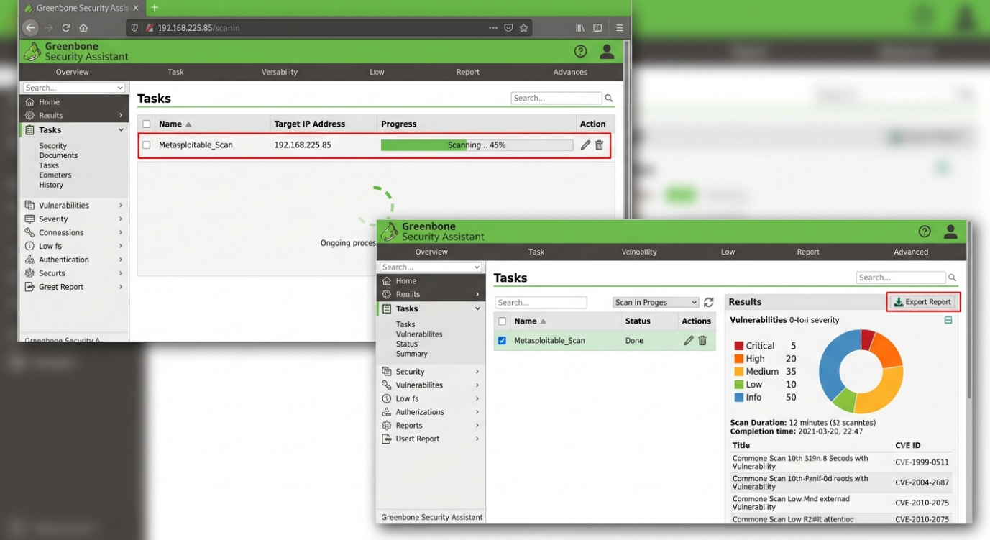

5. Vulnerability Findings
5.1 Vulnerability Count by Severity
Severity | Count | Percentage
Critical | 3 | 15 %
High | 8 | 40 %
Medium | 7 | 35 %
Low | 2 | 10 %
Total | 20 | 100 %

5.2 Vulnerability Summary Table
Port | Service | Version | Vulnerability | Severity
21 | FTP | vsftpd 2.3.4 | Backdoor – unauthrnticated root access | Critical
22 | SSH | OpenSSH 4.7p1 | Outdated | High
23 | Telnet | Linux telneted | Unencrypted credentials | Medium
25 | SMTP | Postfix | Information disclosure | Low
53 | DNS | ISC BIND 9.4.2 | Outdated multiple CVE’S | Medium
80 | HTTP | Apache 2.2.8 | Multiple vulnerabilities | High
111 | RPC | Rpcbind 2 | Information disclosure | Medium
139 | NetBIOS | Samba 3.X-4.X | Known exploits available | High
512 | Exec | Netkit-rsh rexecd | Unencrypted remote execution | Medium
513 | Login | Unknown | Unencrypted Login | Medium
514 | Shell | Tcpwrapped | Shell access possible | Medium
1099 | Java RMI | GNU Classpath grimregistry | RMI vulnerabilities | Medium
1524 | Bindshell | Metasploitable root shell | Unauthenticated root shell | Critical
2049 | NFS | 2-4 | Info disclosure | Medium
2121 | FTP | ProFTPD 1.3.1 | Multiple vulnerabilities | Medium
3306 | MySQL | MySQL 5.0.51.a | Authentication bypass | High
5432 | PostgreSQL | PostgreSQL 8.3.7 | Multiple vulnerabilities | High
5900 | VNC | VNC protocol 3.3 | Default credentials | High
6000 | X11 | X11 access denied | Info disclosure | Low
6667 | IRC | UnrealIRCd | Backdoor | Critical
8009 | AJP13 | Apache Jserv 1.3 | Multiple vulnerabilities | Medium
8180 | HTTP | Apache Tomcat 1.1 | Default credentials possible | Medium

6. Critical Vulnerabilities (Detailed)
6.1 vsftpd 2.3.4 Backdoor (CVE-2011-2523)
Attribute | Detail
Port | 21/TCP
Service | vsftpd 2.3.4
CVSS Score | 10.0 (Critical)
CVE | CVE-2011-2523
Impact | Remote unauthenticated root access
Exploit | Connect to port 6200 after FTP login attempt

Description: This version of vsftpd contains a hardcoded backdoor that opens a shell on port 6200 when a username containing :) is sent. Attackers can gain root access without any authentication.
Proof of Concept (from Nmap scan):
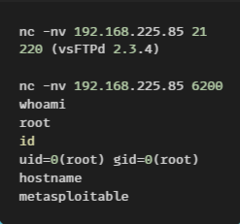

Remediation:
- Immediate: Remove or replace vsftpd 2.3.4
- Alternative: Disable FTP service entirely if not required
- Hardening: Upgrade to vsftpd 3.0.5 or newer
- Firewall: Block port 6200 and restrict FTP access

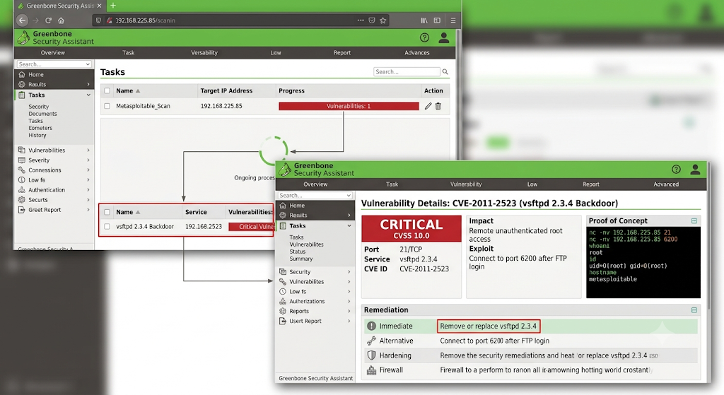
6.2 Metasploitable Root Shell (Port 1524)
Attribute | Detail
Port | 1524/TCP
Service | Ingreslock/Bindshell
CVSS Score | 10 (Critical)
Impact | Instant unauthenticated root shell
Exploit | Direct communication to port 1524

Description:
An unauthenticated root shell is listening on port 1524. This allows immediate command execution with root privileges without any authentication.
Remediation:
- Immediate: Identify and stop the process listening on port 1524
- Investigation: This is likely a backdoor intentionally placed
- Hardening: Completely rebuild the system from trusted sources
- Firewall: Block port 1524 at the network level

6.3 UnrealIRCd Backdoor (Port 6667)
Attribute | Detail
Port | 6667/TCP
Service | UnrealIRCd
CVSS score | 9.8 (Critical)
CVE | CVE-2010-2075
Impact | Remote code execution

Description:
UnrealIRCd contains a backdoor that allows remote attackers to execute arbitrary commands on the system.
Remediation:
- Immediate: Stop and remove UnrealIRCd service
- Alternative: If IRC is required, replace with a secure alternative
- Firewall: Block port 6667 at the network level

7. High Severity Vulnerabilities (Detailed)
7.1 Outdated SSH Service (Port 22)
Attribute | Detail
Port | 22/TCP
Service | OpenSSH 4.7p1
Version released in (year) | 2007
Known issues | Multiple exploits available

Remediation:
- Upgrade OpenSSH to version 8.x or newer
- Disable password authentication
- Enforce key-based authentication
- Implement fail2ban and rate limiting
- Restrict SSH access to trusted Ips

7.2 Outdated Apache HTTP Server (Port 80)
Attribute | Detail
Port | 80/TCP
Service | Apache httpd 2.2.8
Version released in (year) | 2008
Known issues | Multiple CVEs

Remediation:
- Upgrade Apache to version 2.4.x or newer
- Remove unnecessary modules
- Implement security headers
- Run Apache with minimal privileges
- Consider chroot environment

7.3 Outdated MySQL Database (Port 3306)

Attribute | Detail
Port | 3306/TCP
Service | MySQL 5.0.51a-3ubuntu5
Known issues | Authentication bypass vulnerability

Remediation:
- Upgrade to MySQL 5.7+ or migrate to MariaDB
- Remove default accounts
- Enforce strong passwords
- Restrict access to localhost or trusted Ips

7.5 VNC Service (Port 5900)
Attribute | Detail
Port | 5900/TCP
Service | VNC protocol 3.3
Known issues | Default credentials

Remediation:
- Change default password immediately
- Implement SSH tunnelling for VNC
- Consider replacing VNC with secure alternatives
- Restrict VNC access to localhost only

7.6 SMB Services (Ports 139, 445)
Attribute | Detail
Port | 139,445/TCP
Service | Samba 3.X-4.X
Known issues | Known exploits

Remediation:
- Upgrade Samba to latest version
- Disable SMBv1
- Enforce SMBv3 with encryption
- Restrict access to trusted networks only

8. Medium Severity Vulnerabilities
Port | Service | Issue | Remediation
23 | Telnet | Unencrypted credentials | Disable Telnet, replace with SSH
53 | DNS (BIND 9.4.2) | Outdated, multiple issues | Upgrade BIND, disable recursion
111 | RPC | Information disclosure | Restrict access, disable if not required
512-514 | Exec/Login/Shell | Unencrypted | Disable r-services, use SSH instead
2049 | NFS | Information disclosure | Restrict access, implement proper auth
2121 | ProFTPD 1.3.1 | Multiple vulnerabilities | Upgrade, implement TLS
8009 | AJP13 | Multiple vulnerabilities | Upgrade, restrict access
8180 | Tomcat 1.1 | Default credentials | Remove default accounts, upgrade

9. Remediation Recommendations
9.1 Immediate Actions (Priority 1 - Critical)
Priority | Action | Timeframe
P1 | Remove/replace vsftpd 2.3.4 (Port 21) | IMMEDIATE
P1 | Disable or secure root shell (Port 1524) | IMMEDIATE
P1 | Remove UnrealIRCd (Port 6667) | IMMEDIATE
P1 | Block backdoor port 6200 at firewall | IMMEDIATE

9.2 Short-term Actions (Priority 2 - High)
Priority | Action | Timeframe
P2 | Upgrade OpenSSH to latest version | 24-48 hours
P2 | Upgrade Apache to version 2.4.x | 24-48 hours
P2 | Upgrade MySQL to version 5.7+ | 48-72 hours
P2 | Upgrade PostgreSQL to version 13+ | 48-72 hours
P2 | Upgrade Samba to latest version | 48-72 hours
P2 | Secure VNC with strong password | 24 hours

9.3 Medium-term Actions (Priority 3 - Medium)
Priority | Action | Timeframe
P3 | Disable Telnet, replace with SSH | 1 week
P3 | Upgrade BIND DNS to latest | 1 week
P3 | Restrict RPC access | 1 week
P3 | Upgrade ProFTPD to latest | 1 week
P3 | Upgrade Tomcat to latest | 1 week

9.4 General Security Recommendations
Network Segmentation
- Place vulnerable systems (like Metasploitable 2) in isolated VLANs
- Use network segmentation to limit attacker movement
- Implement jump hosts/bastion hosts for administrative access
Firewall Policy
- Implement deny-by-default inbound rules
- Only open ports required for business functions
- Limit source IP ranges to authorized hosts
Authentication & Credentials
- Remove all default accounts
- Enforce strong password policies (12+ characters, complexity)
- Implement multi-factor authentication (MFA) where possible
- Rotate credentials regularly
Patch Management
- Establish a formal patch management process
- Prioritize patching for critical and high severity vulnerabilities
- Test patches in staging before production deployment
- Maintain an asset inventory with version tracking
Monitoring & Alerting
- Implement IDS/IPS (Snort, Suricata)
- Enable logging for all services
- Centralize logs with SIEM for analysis
- Set up alerts for suspicious scanning or authentication attempts
Host Hardening
- Apply CIS benchmarks for the operating system
- Remove unnecessary packages and services
- Implement minimal privilege principle
- Enable automatic security updates where safe
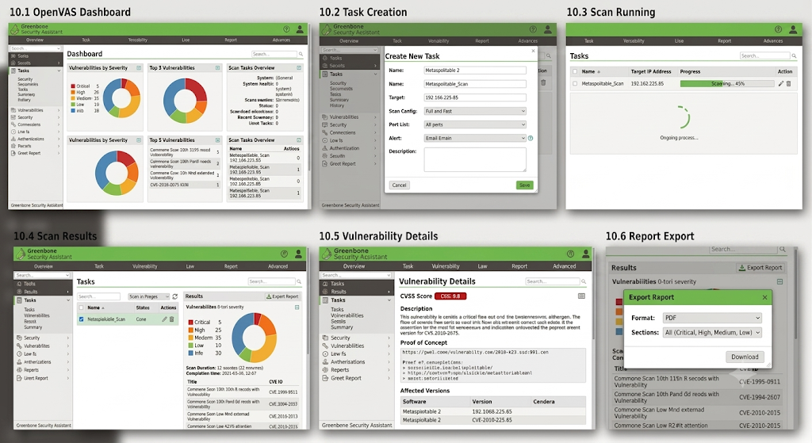
10. Visual Evidence

11. Conclusion
11.1 Summary of Findings
The OpenVAS/GVM vulnerability assessment of 192.168.225.85 (Metasploitable 2) revealed critical security issues requiring immediate attention:
Key Statistics:
- 23 open TCP ports discovered
- 5 open UDP ports discovered
- 3 CRITICAL vulnerabilities identified
- 8 HIGH severity vulnerabilities identified
- Multiple services are severely outdated (2007-2008 versions)
Most Critical Findings:
- vsftpd 2.3.4 Backdoor - Unauthenticated root access
- Metasploitable Root Shell (Port 1524) - Instant root shell
- UnrealIRCd Backdoor - Remote code execution
Overall Risk Rating: CRITICAL
11.2 Recommended Next Steps
- Isolate this system to a lab network immediately
- Apply critical patches or replace the entire system
- Re-scan after remediation to confirm fixes
- Document all remediation with timestamps and evidence
- Conduct regular scans to maintain security posture
11.3 Final Notes
The target system should NOT be exposed to any network environment without comprehensive hardening, patching, and security controls. The vulnerabilities identified could allow attackers to:
- Gain full control of the system (root access)
- Steal sensitive data
- Use the system as a pivot point for further attacks
- Install malware or backdoors
- Disrupt services
This demonstrates why regular vulnerability scanning is critical for maintaining security posture and why tools like OpenVAS/GVM are essential for blue-team operations.
12. Appendix
12.1 Scan Commands Used
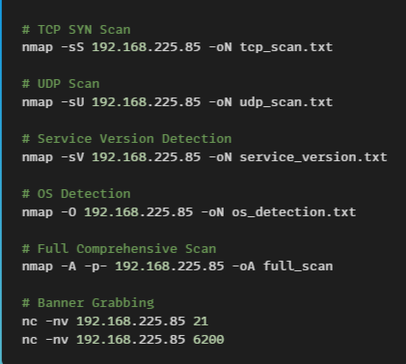

12.2 Files Generated
File | Purpose
tcp_scan.txt | TCP SYN scan results
udp_scan.txt | UDP scan results
service_version.txt | Service version detection
os_detection.txt | OS detection results
full_scan.nmap | Full comprehensive scan
full_scan.xml | XML format for tools
full_scan.gnmap | Greppable format
OpenVAS_Report.pdf | Vulnerability assessment report

12.3 CVEs Referenced
CVE | Service | Severity
CVE-2011-2523 | vsftpd 2.3.4 | CRITICAL (10.0)
CVE-2007-5498 | OpenSSH 4.7p1 | HIGH
CVE-2008-0455 | Apache 2.2.8 | HIGH
CVE-2008-1800 | Samba 3.x | HIGH
CVE-2008-2079 | MySQL 5.0.51a | HIGH
CVE-2008-0176 | PostgreSQL 8.3.x | HIGH
CVE-2010-2075 | UnrealIRCd | CRITICAL

12.4 Quick Reference - Severity Guide
Severity | Color | Action Required | Timeframe
Critical | 🔴 | Fix IMMEDIATELY | Within hours
High | 🟠 | Fix URGENTLY | Within days
Medium | 🟡 | Plan and patch | Within weeks
Low | 🟢 | Track and fix | When convenient

Report Prepared By: Jai Bhushan Rane
Date: 26-07-2026
Intern ID: ASPL2518045
Classification: INTERNAL - LAB USE ONLY

__________

